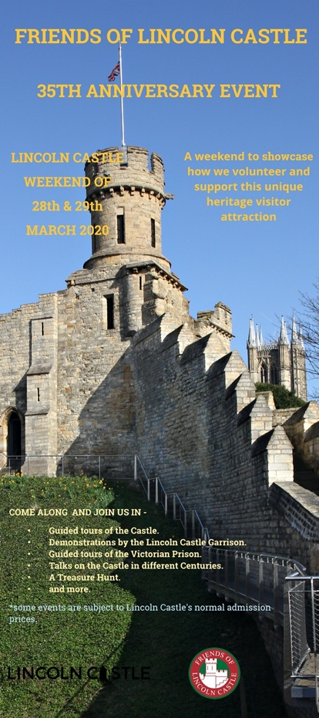

Friends of Lincoln Castle to hold an 'Showcase Weekend' to celebrate 35th Anniversary
To celebrate 35 years since its' formation, 'The Friends' have announced that they planning to hold an event within Lincoln Castle to spotlight its' three active groups.
This event will take place on the weekend Saturday 28th and Sunday 29th March 2020 alongside the City wide 'Discover Lincolnshire' weekend.
Visitors will be able to participate in Guided Tours of the Castle Bailey, the Victorian Prison and for the first time in several years the Castle Walls. Additionally, a series of talks about Lincoln Castle during various centuries of its' 952 year history are planned. The Lincoln Garrison will also be demonstrating a snapshot of medieval.
A full programme of events will be announced shortly so in the interim why not make a note of the dates in your diary!

