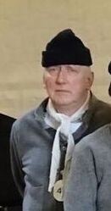

29th August 2019

PETER TURNBULL
It is with much regret the we have learned that Castle Guide and Prison Volunteer, Peter Turnbull, has passed away suddenly.
Peter was a popular and very well-respected member of FOLC. He was an active Guide who provided informative Tours for visitors. He was also a member of the Prison Group, where he played Prisoner 47 - William Clarke, The Lincolnshire Poacher.
Peter will be greatly missed.
Our thoughts and condolences go to his wife and family.

