​AUGUST 2019

GUIDES TO PROVIDE SPECIAL THEMED TOURS OF LINCOLN CASTLE

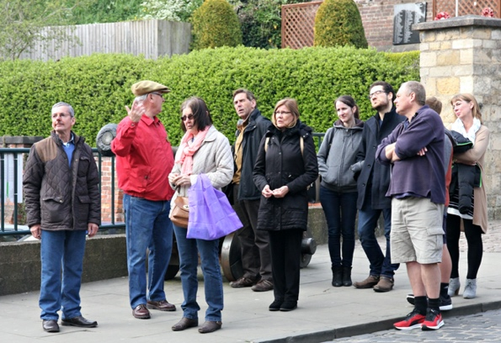

The Guides will be presenting a series of special tours around the Bailey of Lincoln Castle, covering a range of topics, as part of Lincolnshire Heritage Week,.
These tours are free to visitors, so if you are intrigued as to what the Castle was like during the first 30 years of the life of Queen Victoria or what happened in the Castle during the 20th Century or even some of the "Women of Lincoln Castle", why not come along and learn more.
The dates and timings of these tours are as follows:-
​Saturday 14th September 2019
11:00 Lincoln Castle in the First 30 Years of the Life of Queen Victoria.
The tour will describe what the Castle was like when Queen Victoria was Born in 1819, look at some of the buildings constructed before 1850 and some of the people then involved in the Castle.
12:30 Women of Lincoln Castle
A tour of the Bailey with stories about some of the women in the Castle over the centuries.
14:30 Lincoln Castle in the 20th Century
A Bailey tour outlining events and things that happened in the Castle in the 20th Century.
Wednesday 18th September 2019
11:00 Women of Lincoln Castle
Sunday 22nd September
11:00 Lincoln Castle in the First 30 Years of the Life of Queen Victoria.
12:30 Lincoln Castle - A General tour looking at its' history and people who forged it.
14:30 Lincoln Castle in the 20th Century

