7th JULY 2019

2020 LINCOLN CASTLE GUIDES TRAINING COURSE

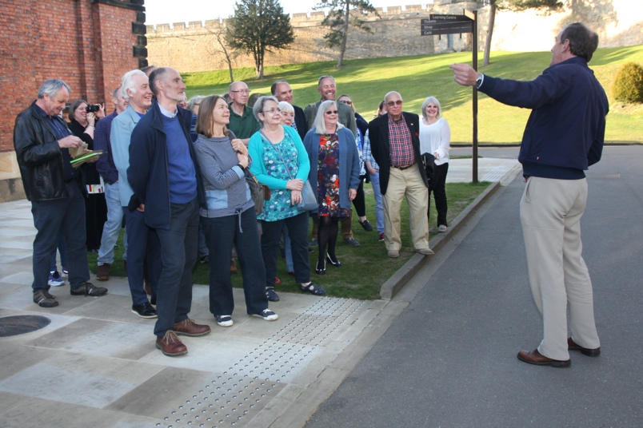

Are you interested in becoming a Guide at Lincoln Castle?
Friends of Lincoln Castle will be running their next Training Course for new Guides between January and March 2020.
The Course starts on Saturday 11th January and applicants will need to commit to approximately 50 hours of training with a lecture on Wednesday Evenings and Practical Workshops on Saturday mornings, culminating with a final exam.
Course spaces are limited.
Applications close on Thursday 31st October 2019.
1st November 2019
​APPLICATIONS ARE NOW CLOSED

