31st January 2019
Friends of Lincoln Castle benefit from donation by local house builder.

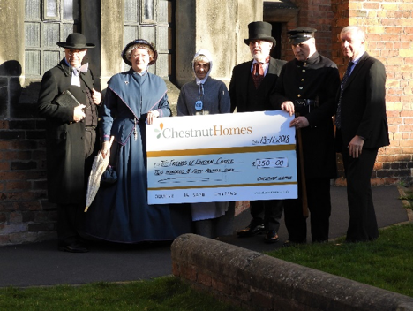

David Newton, Managing Director of Chestnut Homes presents the cheque to the Friends of Lincoln Castle.
Left to right; Brian Holman – playing Rev Henry Richter, Margaret Carstairs – playing Mrs Mary Richter, Jane Bailey – playing Elizabeth Hewitt, Doug Carstairs – playing Governor James Foster, Andrew Brown – playing William Henderson , David Newton, Managing Director of Chestnut Homes

Local house builder Chestnut Homes held its 30th anniversary celebrations at the Victorian Prison in Lincoln Castle, with members of the Prison Group of Friends of Lincoln Castle dressing in period clothing to add to the party’s atmosphere.
Volunteers in period costume made such a great impression on guests at a celebration held at Lincoln Castle, that the event’s hosts have made a £250 donation to the group.
David Newton, Managing Director of Chestnut Homes, said: “The FOLC were brilliant on the night of our 30th anniversary celebrations and added a wonderful dimension to our evening in the castle prison. We were more than happy to donate to the group to show our appreciation and help them continue what they do so well.”
Margaret Carstairs (70), who has run the group of period prison characters said “The donation was quite unexpected as we do this as volunteers to help the castle. We were overwhelmed to be honest but delighted as we’ll put the money back into the group and it will go towards new costumes.”

